Game Dev-log #1

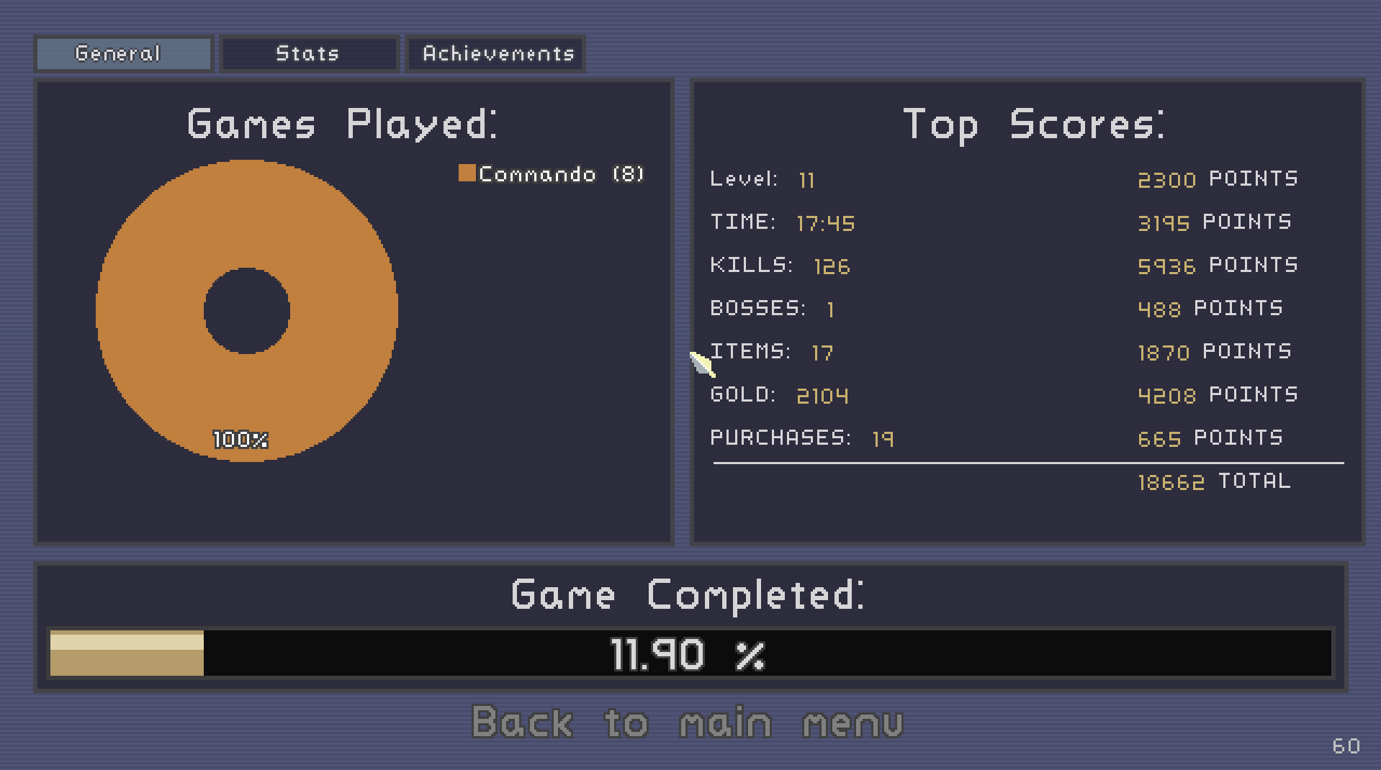

When playing the game there were multiple objects in the game.

1. One was the chests that would open if you have a certain amount of coins. The script probably checked if the user had enough coins and then removed the coins if the user did have enough coins. Afterwards the script would simply drop a random item.
2. Another game object was the enemies like the fire ball things. I forgot their name but they would be really annoying to fight. The scripting for these game objects would be much more complicated as you must involve movement and their attack. Their attack was that they would shoot a fireball at you that would deal a good amount of damage. They are also super fast too.
3. The easiest game object to find is the player. The player starts as one of multiple characters to choose from and is probably the hardest to script. Each character has 4 movesets to script with each move being unique. The FMJ move was really useful and could be hard to code as it involved shooting a piercing shot that would hit multiple enemies at once.

I would pitch Risk of Rain most likely as a action-survival game since it feels like you are always at risk when playing. If you wait for too long the enemies only get harder and harder and you are forced to rush the game to get as many upgrades as possible while also constantly checking ur health to make sure you do not die. To investors the action packed gameplay is perfect for people who enjoy the adrenaline rush in games.

One thing that I personally would add to Risk of Rain is a more choice based chest system. The randomized items make playing the game feel more like a game of chance as to whether you get a good item or a piggy bank that is really useless. I wish there was atleast a choice between 3 randomized items to make the game feel less rng based and more choice based. That is the only gripe I have with the game as sometimes I just get items that really just suck that end up costing me when im fighting the boss or on the next level.

A potential idea for my next game could be an action packed game like risk of rain. However I would love for the game to be in 3d so there is much more freedom and movement involved when playing the game